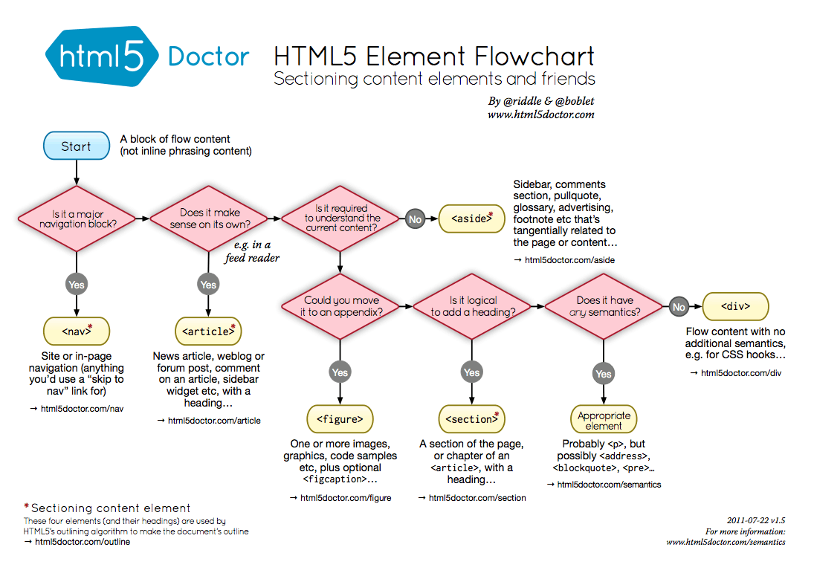

Picture Resize – www.picresize.com

Picture Optimize – www.tinypng.com

Site Speed – developers.google.com/speed/pagespeed

Stock photos – pexels.com, unsplash,canva,flaticon.com for free icons, freepik